**Kickstarter Analysis**

**By: Siobhan Scott**

**Overview**

An analysis is a way of taking information and breaking it down so that it is understandable. The goal of the Kickstarter Analysis is to help Louise gather information to Kickstart her play “Fever”. Louise has a specific budget of $10,000 and would like to know if that is enough for her to get her play running and have a successful outcome in the United States. The information used in Louise’s Kickstarter Analysis came from an Excel spreadsheet. The spreadsheet contained information on 4115 Kickstarter campaigns in nine different countries. The information supplied were Kickstarter Names, brief description (blurb) of the campaign, the goal amount, pledge amount, country, currency, deadline, launch date, the number of backers and the category type of the Kickstarter.

**Analysis & Challenges**

**Analysis**

I performed my analysis in several different ways since Louise is interested in interested in possibly creating a play in the United States or Great Britain. I utilized the Kickstarter campaign spreadsheet and familiarized myself with the content of the sheet. There were several formatting changes that I performed such as resizing, making numerical data match and adjusting columns to clearly see all the information. The data needed to be filtered to match Louise’s current budget so we can create a comparison to similar campaigns. The information was sorted based on pledge and goal. Many of the campaigns had small margins where they had not met their goal amount. It is important to visually see which Kickstarter campaign had fallen short, this was done with conditional formatting.

For Louise to have data that she can understand, a pivot table was created. The data was filtered by subcategory to make sure that she was getting a similar comparison. The outcome was that of Great Britain’s, 604 Kickstarter campaigns, the most successful were “plays” and they were most successful in the Springtime. For Louise’s campaign to be successful timing will be important.

**Below is a line chart of Great Britain’s theatre launches:**

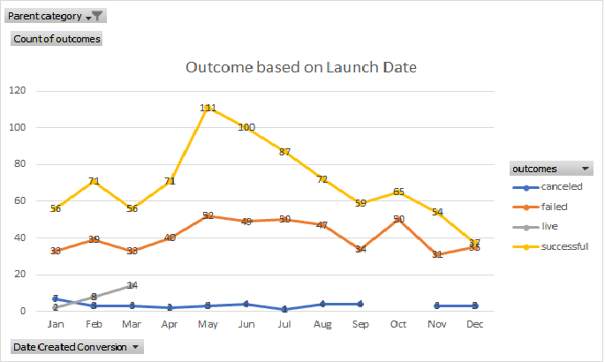”.

Louise will need statistical data to help make her campaign decision. To help Louise formulate her strategy the central tendency was calculated. The table shows the Louis has a $10,000 goal but successful campaigns have not had a goal that high. However, there are some campaigns or outliers that were much higher. Yet, the failed projects had a mean goal like Louise’s. The failed projects also had a lower Median pledge which might have been a contributing factor to their failure and signals that backers did not pledge some reason.

**Below is a table showing the Statistical Data of U.S. campaigns:**

Since Louise is considering multiple markets for her play it is important to see if the £4000 budget will be viable in Great Britain’s Musical Kickstarter campaigns. Looking at the graph the campaign goals, most of them are lower than Louise’s budget and relied very little on pledges. She will either need to change her budget and try to produce it for less or try and increase her budget and get more pledges.

**Graph of Great Britain Musical Kickstarter Goals:**

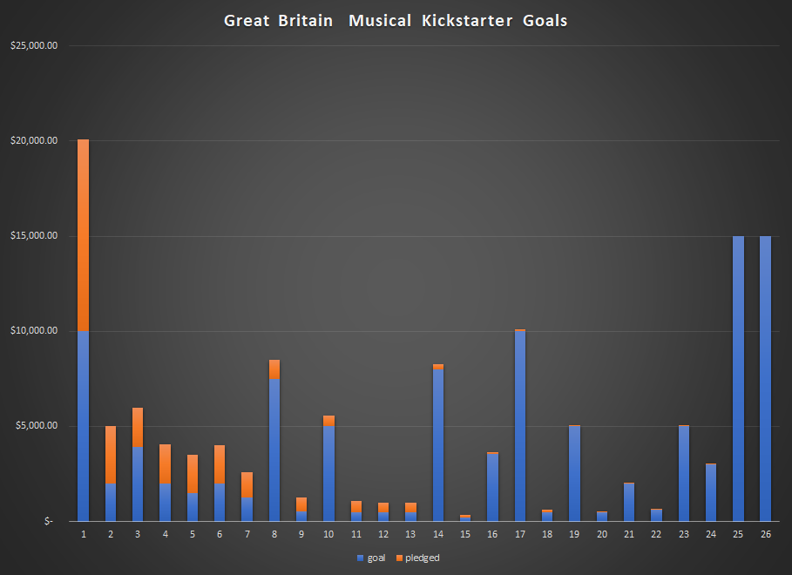

**Challenges**

There were some challenges with this data set. While ever Kickstarter campaign had a goal, they did not have a financial backer. This left the data set with an error when it was divided by “0” when trying to find the average donation. Using a nesting function allowed the data to return a zero-value input, instead of an error message.

Another challenge was that not all the data was in information that was understandable. The deadline and launch date were in UNIX and had to be converted to a date that was readable.

The data set itself is limited to only nine countries. This may not be an accurate view of successful or failed campaigns since there is a limited amount of data. The data set also does not consider any socio-economic data. Socio-economic data may have an impact on pledge success or the number of backers.

**Results**

Louise has two different countries that she is looking at showing her play. They both have different budget limitations and different Kickstarter campaign success. However, the results were similar. Louise’s budget for either market, $10,000 or £4000 were both above other campaigns that were successful. In the United States campaigns with a mean goal like Louise’s failed. The differences were the pledges and the goals. In the United States the mean pledge and mean goal were similar amounts. Whereas in Great Britain many of the Kickstarter campaigns had little pledges. Louise may not be successful with the current Kickstarter goals. She may need to look at other countries, a larger data set for additional information, change her goal or seek more pledges.